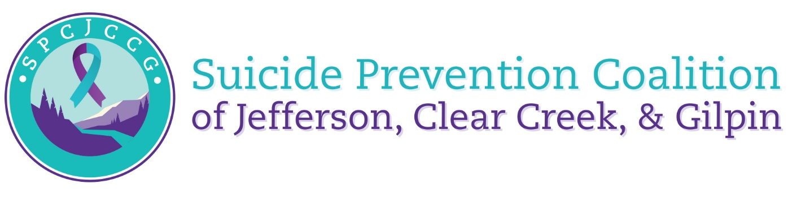

Introductions and Icebreakers (15 min)
- In attendance:

  - Rachel Vilner , JCMH Suicide Prevention Coordinator
  - Rebecca Mitchell, JCMH Community Engagement Coordinator
  - Kiley Floren (guest presenter) – Practical Statistics
  - Annette Cannon, JeffCo Coroner
  - Alisa Sharks, Counseling Center at CCU
  - Erica Haag, Resilience 1220
  - Ashleigh Phillips, Common Spirit
  - Sophie West, Jeffco Health Department
  - Marie Larson, Gilpin County Public Health

Workgroup Updates (30 min)
- High-risk Industry update (Rebecca)
  - Rebecca, Rachel and James Gallagos have met with key community members in the construction and safety industry. Developing a drop down menu of mental health services that the Coalition can share with high risk companies (right now focusing on construction) to offer support to employers and employees. Including designing
  - If coalition members have interest in joining this workgroup or have any connections to share with the group please contact James, Rebecca and Rachel.
- Economic Stability and Support update (Erica)
  - A workgroup that met two weeks ago and took off running. Presentation regarding Get Ahead at this workgroup included information on tax credits for families that can help keep families out of poverty. Link for reference: Get Help — Get Ahead Colorado
  - Amy from EChO was present and discussed the impact of economic stability in the rural communities and that advocates for those in need are in need themselves of more support.
  - Kelly F. with the CO gov. office is working on sharing economic support initiatives that we need to be aware of. Once those are shared, will be shared with coalition.
  - Discussed including the CHAT assessment team for Clear Creek Health and discussions around postvention and education to reach individuals in crisis.
  - Focus for next meetings includes a needs assessment from different organizations to come up with a plan to “Help the helpers” to work on preventing burnout.
  - Will be inviting Kendra with Foothills to the next meeting.
  - Please let Erica, Rebecca and Rachel know if you have any insights, resources, or ideas or want to get involved with this workgroup.
- Faith-based (Rachel and Alisa)
  - Soul Shop was a success! David was a phenomenal instructor, encouraging folks to get comfortable talking about mental health and suicide. He encouraged participants to choose their three go to people I a crisis and equipped participants with confidence.
  - Would like to host further Soul Shops and continue outreach in the faith-based community.
  - Please contact Alisa and Rachel if you have any interest in joining this group or have questions about the Faith-based workgroup.
CNC Data: Why it's important and what you get out of it (20 min)
- Survey from Tate Steidley to be sent out. (see below under General updates)
- Guest speaker, Kylie Floren from Practical Statistics. Independent consultant for program planning and evaluation.
  - Kylie has been working with the CNC since 2018 and with JCMH for a year.
  - Ran the Larimer Suicide Prevention Coalition for a time.
  - Works behind the scenes for the CNC grant for the coalition.
  - Understands that data can be burdensome to fill out, and would like coalition members to feel empowered to give feedback on the data to make it more efficient and applicable.
  - The survey should only cover 20 metrics, and there is an incentive. For folks who fill it out they will be put in a drawing to win a $50 gift card.
  - Acknowledges that data has been outdated and late.
  - Sophie shared that she and her team from JeffCO are working on getting real time data with the coroner’s office. She is working on putting together shareable data and feedback within months of receiving it. More to come in future meetings once the structure is in place.
  - Rebecca, Rachel, and Kylie have asked the CNC to work on getting access for ALL coalition members to the data that is being gathered for members to use for their own reporting and other grants. Will discuss next steps within the next few meetings (depending on the timeline of when the data is gathered and synthesized.
  - Kylie will help others access other areas of data if folks need it for their own reporting, and can be reached at: kiley@practical-statistics.com

General Updates: (10 min)
- Local Partners Survey results will be shared within the next two meetings (hoping to have them ready by next meeting).
  - Please fill out between April 1st through April 15th for the partner survey. Tate Steidley will be sending out. The survey will be voluntary, but does give good information regarding collaboration. Any feedback you have on what is being asked is welcomed as it allows the CNC folks to navigate and change ways to ask for data that make sense and is useful.
- Continued meetings with Rebecca
  - Please look for emails from her, as she makes her way through making personal connections with different coalition members.
Other events coming up
  - May 8th – Erica Haag and Resilience 1220 working on a documentary around how suicide is affecting families. There will be a screening in Colorado and an invitation will be sent.
  - Mental Health Month in May
    - CBHC pushing out MHFA classes and specialty classes, including Spanish MHFA and Veteran MHFA classes.

Action Plan Items
- Kylie to present the data and how to access it at the next meeting.  - Invitations from Rebecca and Rachel to future work group meetings.  - Coalition members to fill out evaluation for partner survey for the CNC and give feedback on what is working in the evaluations and what is not, and what folks would like more data on and how to access the data. | - Please send any events to Rebecca and Rachel to share to the coalition – especially with May being Mental Health Month  - Erica Haag to send out information regarding the documentary.

