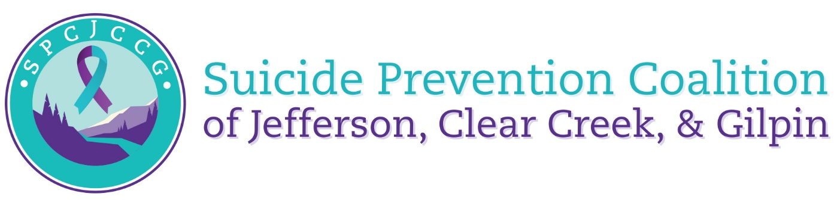

Meeting Agenda
Wednesday January 18, 2024

Introductions and Icebreaker 12:00 – 12:25
CNC Overview from Dymond and Kaleigh 12:25 – 12:45
Updates 12:45 – 1:10
Workgroup Updates 1:10 – 1:15
Survey 1:15 – 1:30

